IREVOLUTION

A DATA-DRIVEN EXPLORATION OF APPLE’S iPhone IMAPCT IN INDIA

INTRODUCTION:

1.1 OVERVIEW

The world has changed because of the increasing use of smartphones, which have improved communication, connected people, and revolutionized many different businesses. With its main product, the iPhone, capturing markets around the world, Apple Inc. has emerged as a prominent player among the top smartphone makers. India, one of the economies with the greatest economic growth, has seen a tremendous increase in smartphone usage, making it an interesting market to study the effects of Apple's iPhone.

1.2 PURPOSE

Through this project we can identify the flaws and pros in the apple industry's growth. In some countries the growth is consistent and in others it is not. By investigating the conditions and purpose of the customers, we can increase the influence of the industry. The data clearly reflects the apple products quantity, quality, marketing, etc. so to change the state of current apple industries we may use this. So, this is the purpose.

PROBLEM DEFINATION AND DESIGN THINKING

2.1 EMPATHY MAP

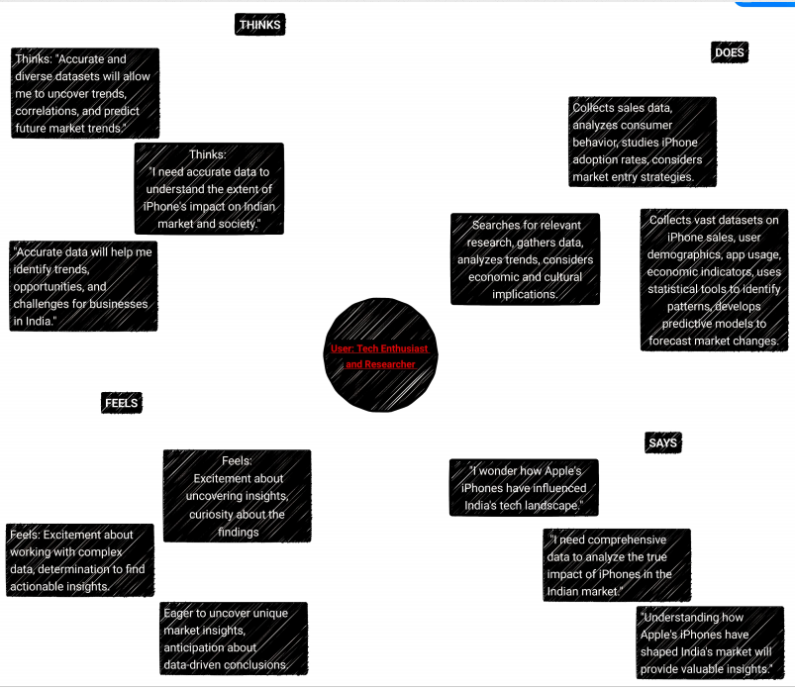

2.2 IDEATION & BRAINSTORMING IDEAS

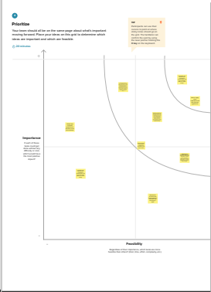

RESULT

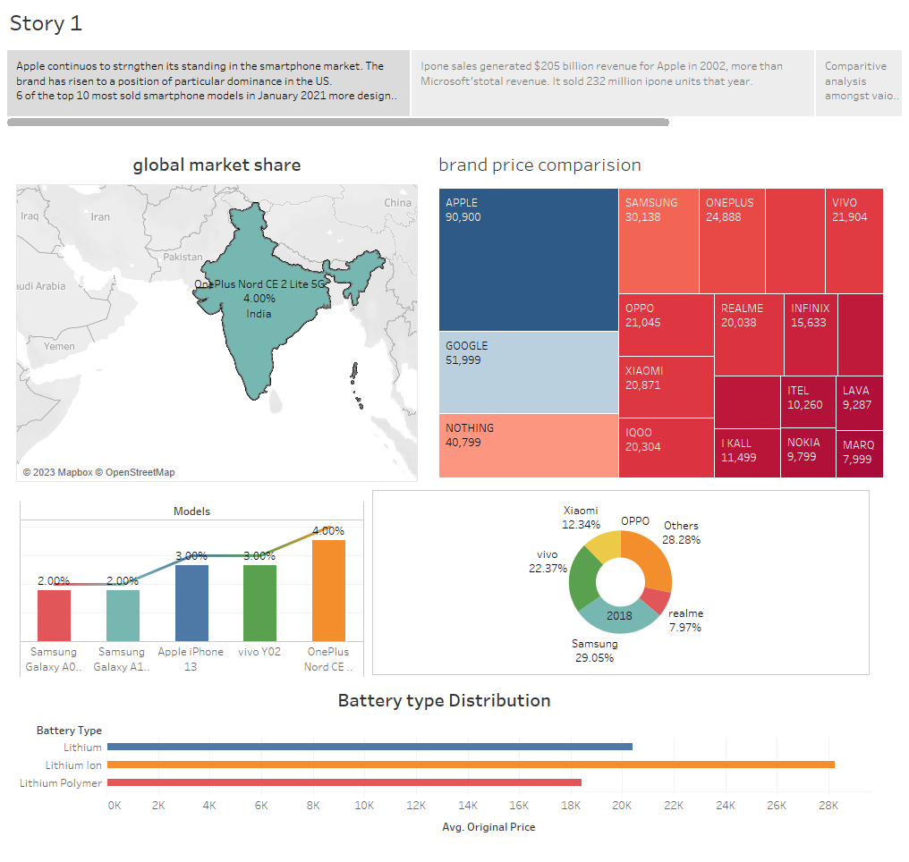

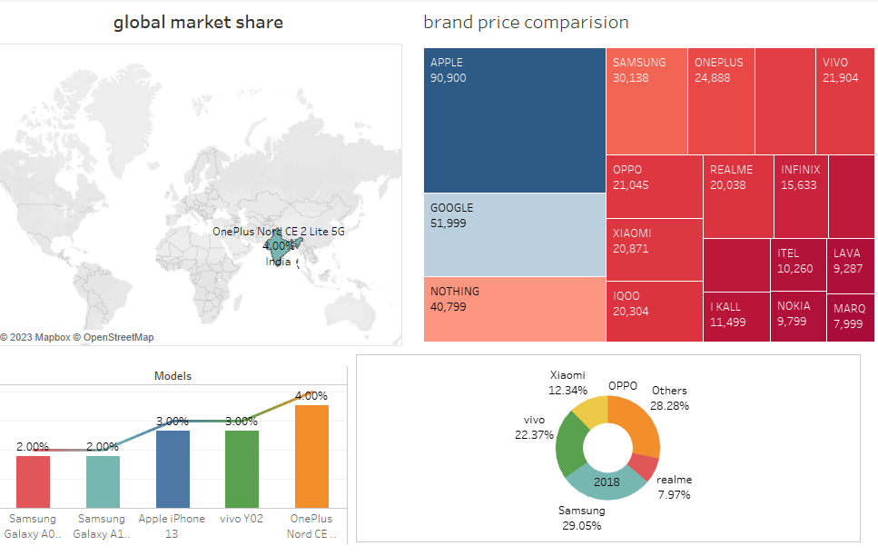

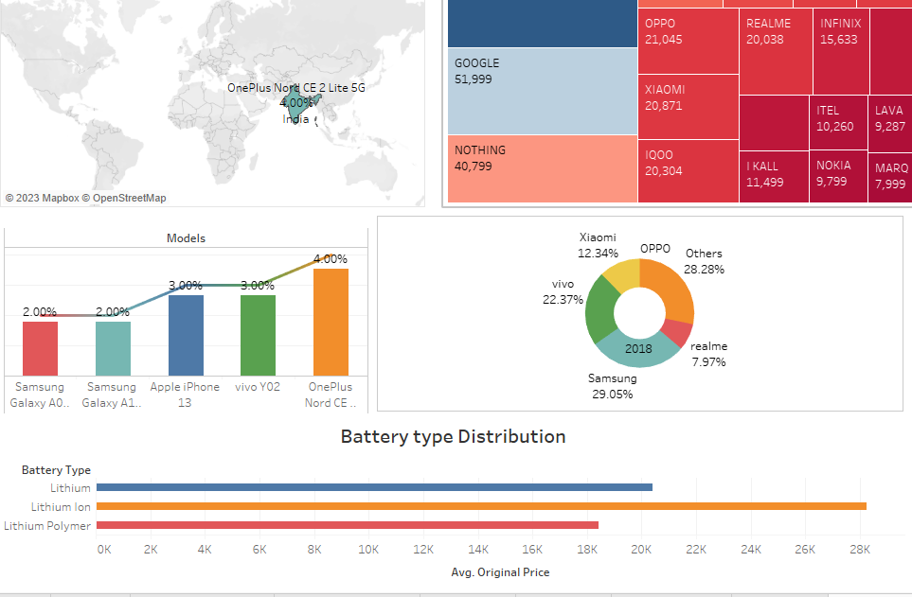

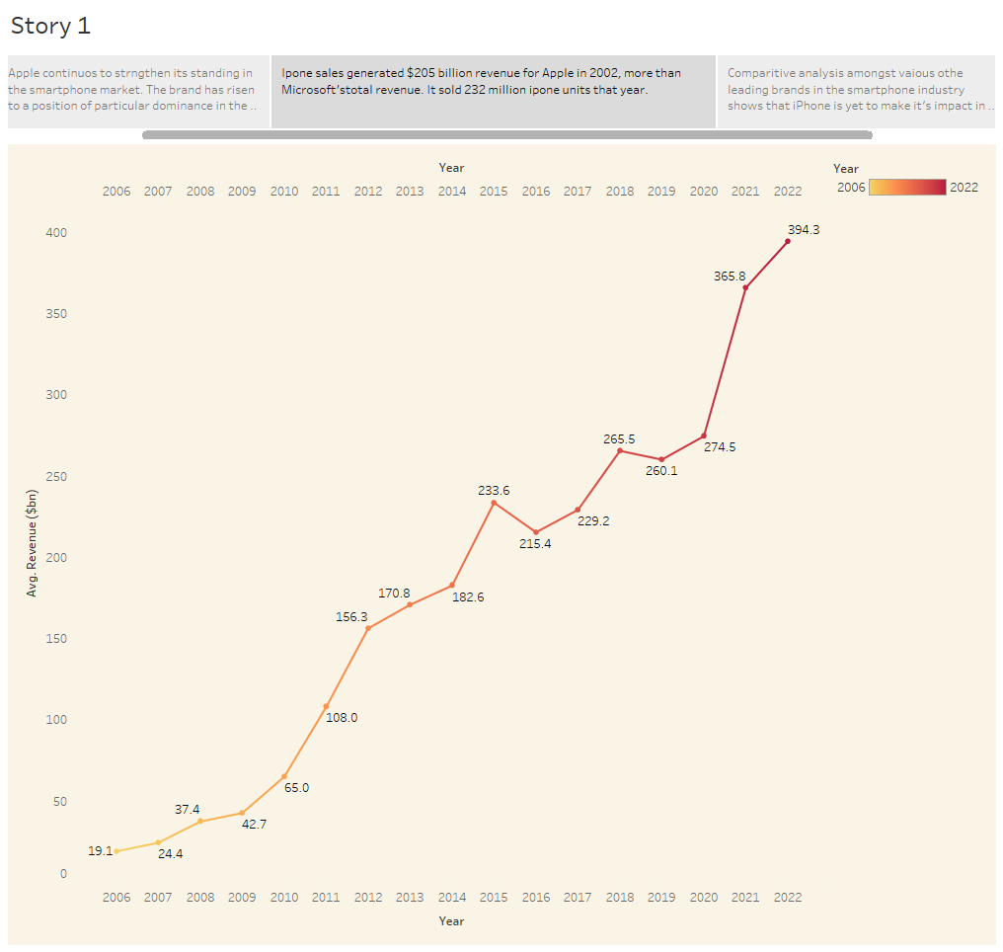

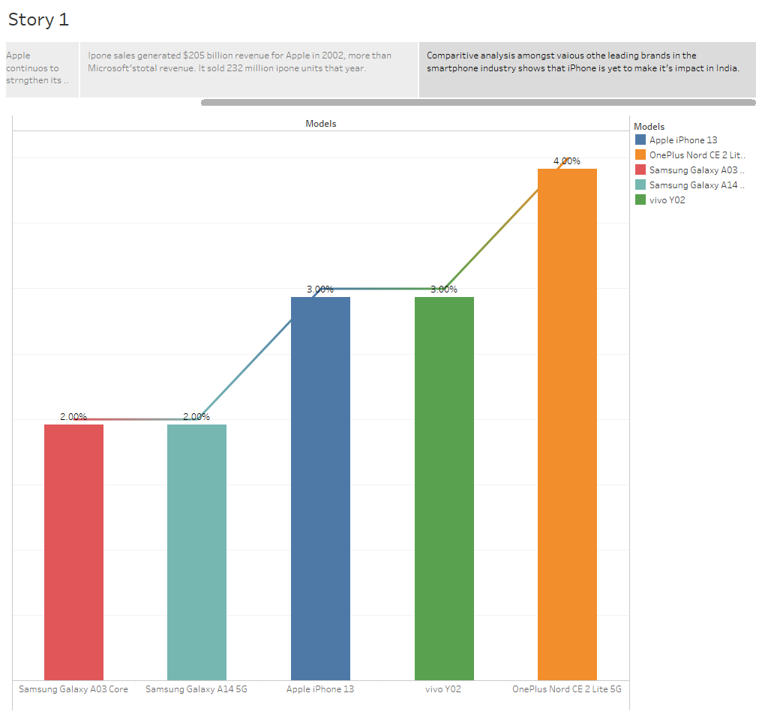

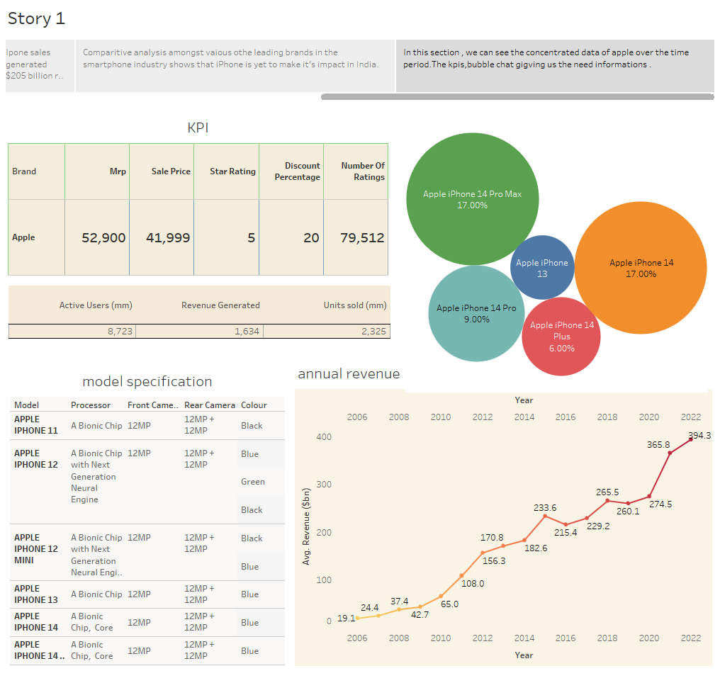

The above graph and visualizations show us a clear view about the data.

ADVANTAGES & DISADVANTAGE

* Apple has the upper hand in many countries. The data shows minor defects in some areas and time periods. So, by going through the visualization we can rectify it.
* The price drop and rise shows the production of the products, it gives the data of customer
* But it didn’t give the full picture.

APPLICATIONS

This can be applied to the further development of the apple industry in future days. And the interest I personally took is the best application, I guess.

CONCLUSION

Just as I mentioned above It gives the clear vision for both customer and company to make the decision when they must. Meaning it gives the idea to buy it or not. As well as the production side, it gives the idea of past and correction of future!

And personally, it made me a beginner level data scientist.

FUTURE SCOPE

It’ll rise as I expected. Even in the toughest situations while doing, it gives us the future path.